**RESUME**

**PRANITA MESHRAM**

+91 87704 93047

Email Id:

mpranita25@gmail.com

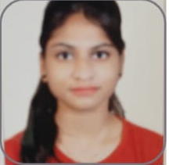

# CARRER OBJECTIVE

# To obtain a challenging career in the IT industry and put all my efforts into the growth of the organization and have a great working environment.

# SUMMERY :-

# An enthusisastic ,punctual & career minded individual with excellent communication and interpersonal skills

# SOFT SKILLS:-

# Communication | Teamwork | Problem-solving

# TECHNICAL PROFICIENCY:-

# Languages:- HTML ,CSS, JAVASCRIPT , C/C++(BASIC ),PYTHON.

# DATABASE:- SQL, MY SQL

# EDUCATIONAL QUALIFICATIONS:

# Pursing Bachelor’s of computer application(BCA) from TECHNOCRAT GROUPNOF INSTITUATION. BHOPAL

# Schooling from NEW ST. MARY CONVENT H.S SCHOOL. BHOPAL.

**WORK EXPERIENCE -**

Fresher

# STRENGTH & HOBBIES

* Hard & Smart Working | Honest & Punctual | Good Communication skill | Dancing , cooking.

# DECLARATION:-

I Here by declare all the above -mentioned information is true amd correct to the best of my knowledge.

(PRANITA MESHRAM)

# 